**Step-By-step process with images**

**AIM: Create an orchestration pipeline for training and inference in spark using AWS Glue**

step 1: created a s3 bucket and stored bank_dataset.

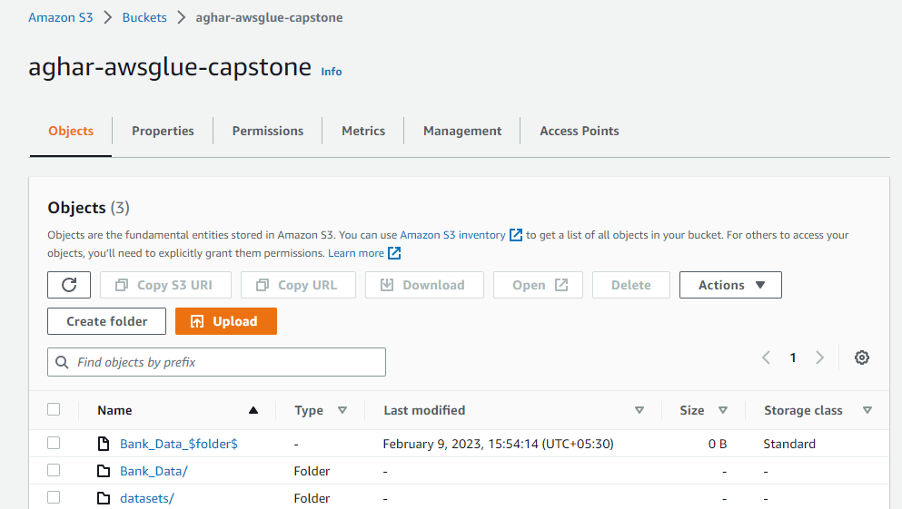

Step 2: created crawler name Aghar_Bankdata_1 for loading the dataset from s3

Step 3:The result from step 2 is loaded data from s3 is stored in database table created in glue

Table Name: raw_bankdata

Step 4: created a job for cleaning the dataset.

Job name: BankData_cleaning. (the data for cleaning is loaded from table created using crawler)

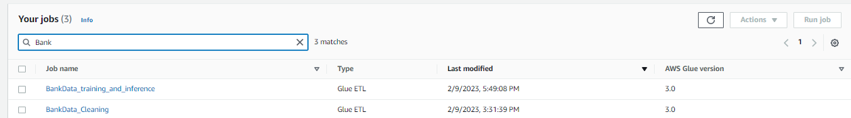

Step 5: The cleaned data is automatically stored to s3 using configuration in notebook.

Step 6: created crawler name Aghar_Bankdata_2 for loading the cleaned_dataset from s3.

Step 7: The result from step 6 is loaded cleaned data from s3 is stored in database table created in glue

Table Name: cleaned_bankdata

Step 8: created a job for preprocessing the data and inferences.

Job name: BankData_training_and_inference

Step 9: The preprocessed(train and test) data and output metrics(inference data) is automatically stored to s3 using configuration in notebook.

Step 10: created a conditional and on demand trigger for the jobs and crawlers.

Step 11: created a workflow and added the triggers in order and allow it run and checked whether it is succeeded.

